Chapter 10 Byrne

1. Multitrait multimethod = testing for validity
   1. Convergent validity – how much do the different scales measure the same trait
   2. Discriminant validity – how much different scales underlying scales measure different things
   3. Method effects – how much of what is going is due to that scale in particular, that method of measuring things
2. AMOS tip
   1. Fit to page icon – making the model fit in the space you are given to draw stuff
3. CFA – MTMM
   1. Paper to reference – Widaman (1985)
   2. Use a set of nested models and examine the X2 difference to see if there is convergent-discriminant validity
   3. Different models to test
      1. Correlated traits / correlated methods CTCM – Model 1
         1. Least restrictive about parameters
         2. Must fix factor variance
         3. (first number = factor mean , second number = factor variance)
         4. Remember normally we set one of the loadings to a question to 1 🡪 now we are going to fix the variance so you can estimate the loadings instead 🡪 one thing always needs to be fixed
         5. To fix: object properties > parameter > 1 in the variance box
         6. Estimation of this model may never be valid (negative error variances)
            1. Solution may be to fix the error variance to be equal to a similar one that’s about the same size
      2. No traits / correlated methods – Model 2
         1. Eliminate the traits side of the model and compare fit indices
      3. Perfectly correlated traits / freely correlated methods – Model 3
         1. In this model, you must set all the covariance loadings between traits to equal (1)
         2. Compare to the previous models
      4. Freely correlated traits / uncorrelated methods – Model 4
         1. Go back to the Model 1, and then delete the covariances between methods ratings
         2. Compare to previous models
4. Matrix level analyses
   1. Convergent validity = independent measures of the same trait are correlated
      1. Compare Model 1 and Model 2
      2. Significant degrade in model 2 indicates convergent validity
      3. Can also compare change in CFI values
         1. Change is significantly bad at .01
   2. Discriminant validity = examine both traits (independent measures of traits are correlated) and methods
      1. Traits: compare Model 1 to Model 3 (you want model 3 to be really bad)
      2. Methods: Model 1 to Model 4 (you want these to be equal)
   3. Parameters
      1. You want to examine the standardized loadings
         1. You want method variance to be higher than trait variance (convergent validity)
      2. You want to examine the factor correlation matrices
         1. You want these to be low between traits for discriminant validity
         2. You want these to be low between methods for discriminant validity
5. Correlated Uniqueness approach
   1. Instead of adding the latent variables for methods, you intercorrelate the error variances associated with those terms
      1. Works better at giving you a proper solution
      2. To examine discriminant and convergent validity, you look at the individual parameter level (see above, same steps)
   2. Methods effects – you examine the covariances between error terms, you want the correlations to be high

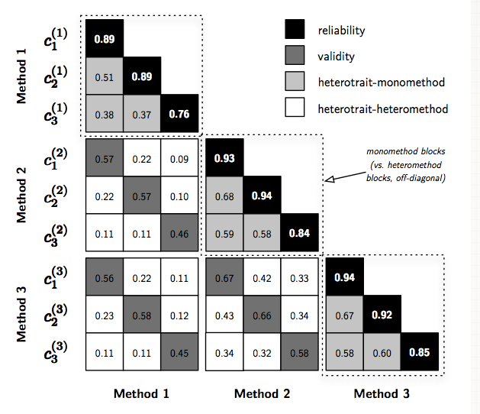

Example:

Methods: Ratings from both husbands and wives

Traits: Martial adjustment (problems and intimacy), FOE (father, mother, fa-mo)

|  |  |  |  |  |
| --- | --- | --- | --- | --- |
| Model | X2 | Df | CFI | RMSEA |
| Model 1  Correlated traits and methods |  |  |  |  |
| Model 2  No traits, correlated methods |  |  |  |  |
| Model 3  Perfectly correlated traits, correlated methods |  |  |  |  |
| Model 4  Correlated traits, uncorrelated methods |  |  |  |  |
| Model 5  Correlated uniqueness |  |  |  |  |

|  |  |  |  |  |
| --- | --- | --- | --- | --- |
| Model | X2 | Df | Critical X2 | CFI |
| Convergent Validity  Model 1 – 2 |  |  |  |  |
| Discriminant Validity Traits  Model 1 – 3 |  |  |  |  |
| Discriminant Validity Methods  Model 1 – 4 |  |  |  |  |

LOADINGS

Husband Ratings

|  |  |  |  |  |  |  |
| --- | --- | --- | --- | --- | --- | --- |
|  | Probs | Intimacy | Father | Mother | Fa-Mo | Hubs |
| Probs |  |  |  |  |  |  |
| Intimacy |  |  |  |  |  |  |
| Father |  |  |  |  |  |  |
| Mother |  |  |  |  |  |  |
| Fa-Mo |  |  |  |  |  |  |

Wife Ratings

|  |  |  |  |  |  |  |
| --- | --- | --- | --- | --- | --- | --- |
|  | Probs | Intimacy | Father | Mother | Fa-Mo | Wife |
| Probs |  |  |  |  |  |  |
| Intimacy |  |  |  |  |  |  |
| Father |  |  |  |  |  |  |
| Mother |  |  |  |  |  |  |
| Fa-Mo |  |  |  |  |  |  |

Correlations

|  |  |  |  |  |  |  |  |
| --- | --- | --- | --- | --- | --- | --- | --- |
|  | Probs | Intimacy | Father | Mother | FaMo | Hubs | Wife |
| Probs |  |  |  |  |  |  |  |
| Intimacy |  |  |  |  |  |  |  |
| Father |  |  |  |  |  |  |  |
| Mother |  |  |  |  |  |  |  |
| Fa-Mo |  |  |  |  |  |  |  |
| Hubs |  |  |  |  |  |  |  |
| Wife |  |  |  |  |  |  |  |